Chris and Lotta’s Prayer Update November 2019

Dear friends and mission partners,

“We proclaim how great you are and tell of the wonderful things you have done.” (Psalm 75:1)
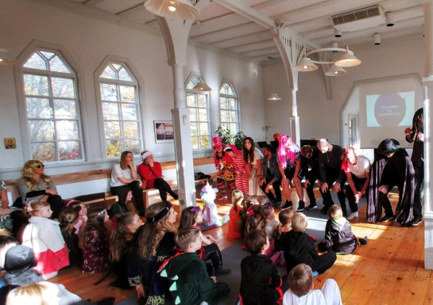
After four long years of waiting for an apartment in Åkersberga (Stockholm), we finally got one! We counted how many times we have moved around since we came back from our time in Serbia and we came up with 7 moves in 5 years. And now we are heading towards our 8th and hopefully, that will be our last move in a very long time. The big moving day is in February 2020. There are no words that can explain our gratefulness to the Lord for his faithfulness! And thank you all for all your prayers concerning our living situation.
We are now in the middle of our high peak and there is so much we would like to finish before Christmas (can hardly believe that Christmas is just 7 weeks away). We are in the middle of preparing for our next family service and we pray and hope that it will be well attended.
In our last update, we wrote about the upcoming Hallåvän party. There were more than 40 people from the community both children and grown-ups that turned up for Hallåvän. We had two intensive hours with games and laughter, good coffee, cake and chats with the visitors. All in all a good event and a good opportunity to meet new people.
We still have no news about our venue, but at the same time we have peace in our hearts and we know that the Lord has a good solution.

Praise giving:
- Our new apartment
- Lotta’s teaching in the bible school, and Chris’ one on one which goes very well
- Hallåvän that went well and for all the new people we connected with
Prayer points:
- Please continue to pray for the venue
- For the upcoming family service
- For our health and strength, patience and endurance in our ministry

Blessings from us
Chris & Lotta
* Hallåvän means Halloween

